Joseph Ayo

Module 3.3 Assignment – CSD 310

3NF:

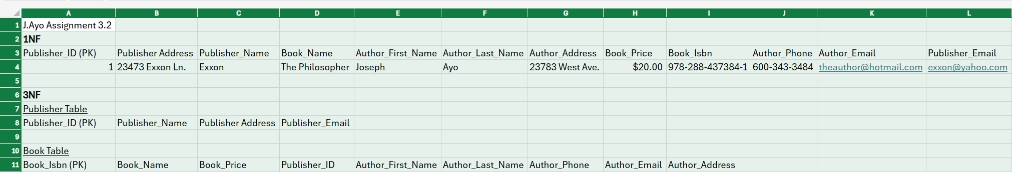

Assumptions:  
PK stands for primary key.  
An important assumption we make is that there is only one author for each book. This allows us to use only 23 tables. If we did not assume this, we would need to consider the possibility that some books are written by several authors, which would require a separate table to account for the many-to-many relationship between the book isbn and the author-related information.